Press Release
Paris, November 8, 2018
AUGMENTED ACOUSTICS AND NOKIA ENRICH SPECTATOR SOUND EXPERIENCE WITH SUPRALIVE® AND 5G

Developed by Augmented Acoustics, a French startup co-founded by three former Nokia employees, Supralive® is the first patented service that allows spectators at an event (concert, sport, theater, cinema . . .) to enjoy a high-definition and customizable sound experience in real-time. Offered as an option, those who wish to can listen with earphones to the multi-track sound coming directly from the sound engineer's console and go as far as making their own mix.
Through this personalized listening experience, it is now possible to guarantee each spectator "the best seat" in terms of sound quality. The sound is perfectly adapted to the spectator’s desires but also to his or her specific auditory needs thanks to the mobile app’s numerous audio settings which allow them to control the sound.
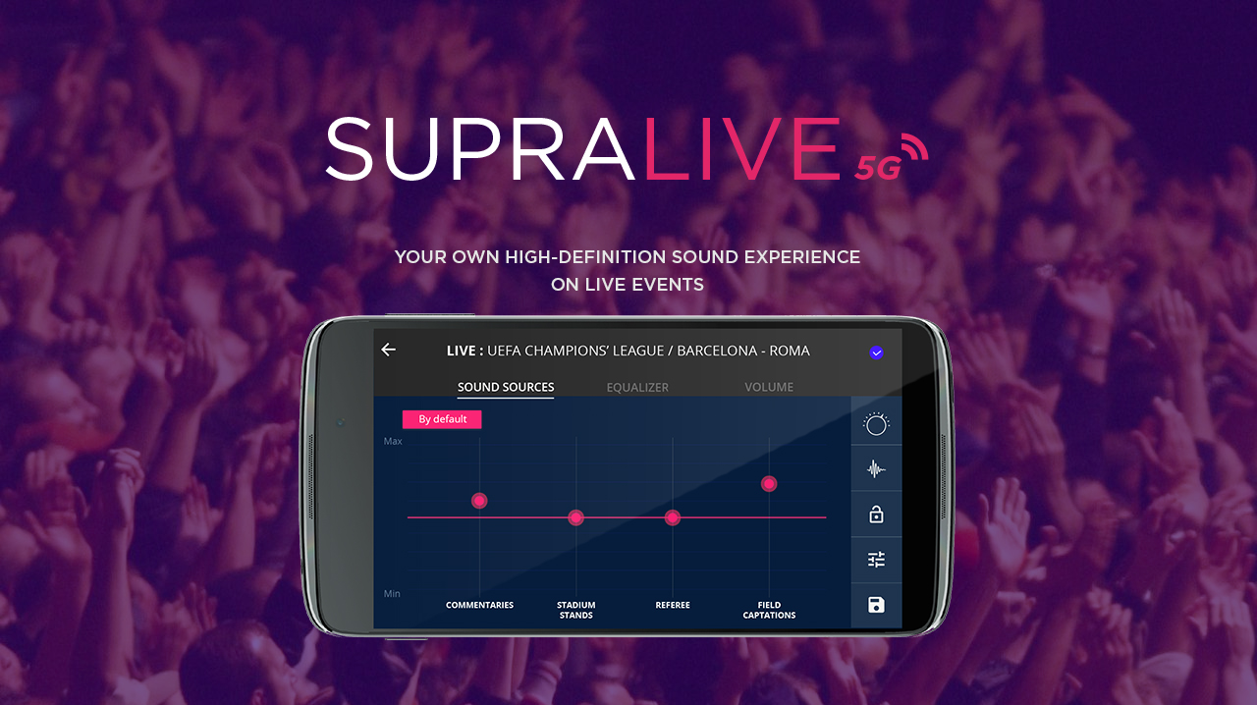
By simultaneously addressing enthusiasts (fans, supporters), the most demanding audiences, and people who are hard of hearing, Supralive® is positioning itself as a new, inclusive and non-stigmatizing solution that propels spectators into the heart of the event.
After successfully deploying Supralive® at more than a hundred events in France and abroad, Augmented Acoustics has just taken a new step in its development by partnering with Nokia to migrate its solution to 5G. The goal is to be able to simultaneously offer Supralive® to an unlimited number of spectators who are equipped with their smartphone, headphones, and a mobile application.

Pascal Agin, Head of 5G R&D - Mobile Networks at Nokia, said: “Through this collaboration with Augmented Acoustics we demonstrate 5G capabilities and new innovative use cases to enhance the consumer experience. Thanks to the ultra-robust low-latency connectivity and network slicing powered by 5G, spectators in stadiums and arenas will enjoy a high-definition and customizable sound experience”.
Stéphane Dufossé, CEO of Augmented Acoustics, said: "Migrating Supralive® to 5G is a fantastic opportunity for Augmented Acoustics. Making the Supralive® service accessible directly via the spectators' smartphone is clearly the future of our service and its potential will be multiplied, at concerts of course, but also in all use-cases where latency issues are a determining factor".
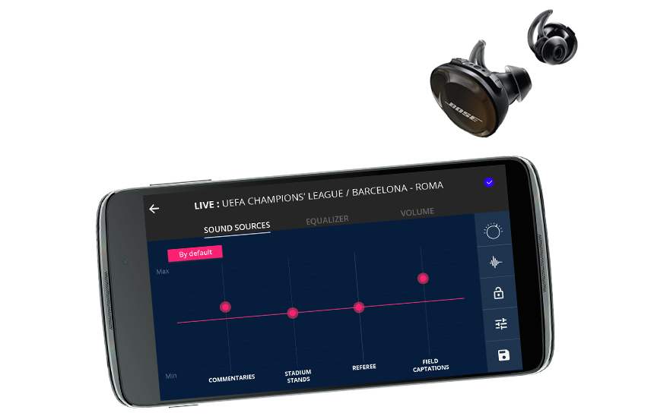

The world premiere of the Supralive® 5G demo, co-developed by Nokia and Augmented Acoustics, will take place at the Nokia 5G Smart Campus Event on November 15 at Nokia’s Paris-Saclay site.
About Augmented Acoustics
Augmented Acoustics SAS was founded by four partners with a shared passion for music, innovation and new technologies. Because live music must be accessible to everyone and in the best conditions, they decided to combine their skills and create Supralive® in order to offer spectators an immersive, interactive, high-definition sound experience.

The team has been rewarded for its work numerous times: winner of the "Symphonic Pitch" competition organized by the “French Tech” and the Brittany (France) Symphonic Orchestra, finalist in the “Be the Future of Sound” competition and in the 2016 Web West Festival, winner of the “Digital France” award, named one of 25 “Parisian gems” by “Usine Nouvelle” magazine in 2015, among “Challenges” magazine’s 100 Start-ups to Invest In in 2016, listed among the “Le Monde” newspaper’s “Best of” 10 best digital innovations at “Futur en Seine” 2015. Augmented Acoustics has “Jeune Entreprise Innovante” (JEI) (Young Innovative Enterprise) status and has support from the BPI, the “Ile-de-France” (greater Paris) Region, and the Paris Enterprise Initiative.

www.augmentedacoustics.com

Media Inquiries:
Stéphanie PLASSE / Chief Marketing and Communication Officer
+33 6 45 58 09 35
stephanie@augmentedacoustics.com

